PART 4: WATER SPECIFIC ISSUES
Health Related Incidents in Wales Potentially Caused by Contaminated Drinking Water 4.1. INTRODUCTION
4.1.1. This document sets out a consistent approach to managing communicable and environmental health related incidents potentially caused by contaminated drinking water. It has been adapted from the Drinking Water Annexes in the Communicable Disease Outbreak Plan for Wales and the Environmental Incident Framework (‘Managing public health risks from environmental incidents: Guidance for Wales).
4.2. PURPOSE
4.2.1. This document sets out a multi-agency process for potential health-related incidents which involve both public and private drinking water supplies. It is designed to guide those involved, encourage collaboration between agencies and clarify process and roles and responsibility. By covering both communicable and environmental incidents, it will ensure a consistent response to drinking water events and facilitate a rapid and effective response to emergency situations.
4.2.2. This document does not override national and local resilience plans or the statutory duties of individual organisations. It does not describe the detailed internal procedures of the water companies and the reporting requirements to the Drinking Water Inspectorate. The principles outlined within the Communicable Disease Outbreak Plan for Wales will be followed and applied as required by the Core Members of the IMT/OCT.
4.3. INCIDENT MANAGEMENT
4.3.1. Responsibility for managing the public health aspects of event, incidents and outbreaks involving water is shared by Local Authorities, Health Boards and Public Health Wales, with the full assistance of the relevant Water Company and their service providers, plus other experts or relevant consultants. In Herefordshire (as part of England), UK Health Security Agency (UKHSA) takes the responsibility along with the relevant local authority.
4.3.2. For the purposes of this document, a water quality event is defined as any biological, chemical or radiological occurrence which by its nature is required to be notified under the Water Supply (Water Quality) Regulations (Wales) 2018 or the Private Water Supplies (Wales) (Amendment) Regulations 2017⁶.
4.3.3. When an event has the potential to have a significant⁷ impact on public health, it can be escalated to an incident and an Incident Management Team (IMT) formed (see FLOWCHART ).
4.3.4. Any party can notify other parties of an incident with potential public health implications and initiate an IMT (see FLOW CHART 2). The criteria for calling an IMT are given in Box 1.
4.3.5. If the incident becomes an outbreak, an outbreak should be declared, the IMT becomes an OCT (see FLOWCHART 4.7). The OCT will operate as laid out in the Communicable Disease Outbreak Plan for Wales.
4.3.6. The primary objective of the IMT or OCT is to protect public health by identifying the source of the contamination and implementing the necessary control measures to minimise or reduce exposure and prevent further spread, recurrence or exposure.
4.3.7. Both the Outbreak Plan and the Environmental Incident Management Guidance outline the membership and duties of the IMT/OCT.
4.3.8. The IMT will usually be chaired by a health or the local authority representative and the Chair will be agreed at the first meeting. However, any member of the IMT can chair by the agreement of the members of the IMT. All meetings of the IMT should be minuted and actions and decisions logged.
4.3.9. The core actions of a drinking water IMT are summarised in FLOWCHART 4.7 and include:
- Undertake a risk assessment to identify the contaminant(s), the source and extent of contamination (see Checklist).
- Identify gaps and information needed to update the risk assessment.
- Evaluate and characterise the risk to public health and likely illness in the community, including defining the population at risk and identifying any high risk / susceptible individuals such as immunocompromised groups, home dialysis patients, health-care settings.
- Declare an ‘Outbreak’ (in line with the principles in 1.3 of the main plan) if there is evidence of communicable disease following the contamination incident.
- Agree and initiate immediate and long-term control measures to reduce exposure. Examples of control measures are given in Box 2. Immediate control measures may have been taken by the water company before the IMT is formed and these should be reviewed by the IMT.
- Communicate to the public and medical professionals including publication of media statements.
- Consider undertaking an epidemiological study to describe symptoms/cases (see Box 3):
- Screening and monitoring of exposed population.
- Provision of medical care such as prophylaxis etc.
- Monitor control measures by continued surveillance for disease/symptoms.
- Live Warning Notices subject to agreed criteria being met.
- Evaluate the management of the incident and make appropriate recommendations for the future.
- Declare the incident over.
- Produce report on the outcome, including recommendations and epidemiological report (if required).
4.3.10. Once the incident is clearly under control, an interim report should be prepared and shared with all the relevant bodies including Welsh Government, DWI, the affected LAs, as well as all IMT members (this is distinct from the reports which the water companies are required to submit to DWI). A final report including recommendations should be produced but may need to be delayed until any epidemiological studies can be completed. Consideration should be given to publishing the incident in a peer-reviewed journal to strengthen the evidence base.
4.3.11. Where an IMT is convened, a record of proceedings will be made and circulated to an agreed distribution list. In the event of a significant emergency, the report will also be circulated to the Welsh Government, the HB, all LAs involved, DWI and any other parties as deemed appropriate by the IMT.
4.3.12. The IMT/OCT shall bear in mind the statutory requirement for the water company to report at 3 working days and 20 working days (and at other times as required) to the DWI. This report will contain details of the investigation, compilation of the results, conclusions, recommendations and lessons learnt. Minutes of all IMT and/or OCT meetings will be appended.
4.4. MEDIA AND COMMUNICATION ISSUES
4.4.1. The IMT should agree a media and communication strategy including which agency should lead communication issues. For mains water, this is usually the Water Company since they will have considerable experience of communicating directly with consumers and will have arrangements in place to deal with issuing advice to people, and the capabilities to handle calls from concerned members of the public during incidents. Furthermore, water companies will be able to identify and map the extent of the affected area and should be able to provide details of the affected area by postcode on their website.
4.4.2. For incidents involving private water supplies, LAs will have the responsibility for communication issues with the duty holder and/or consumer (if affected).
4.4.3. LAs have responsibility for contacting high risk premises including food and drink premises, social housing⁸ and public buildings such as schools.
4.4.4. Public health professionals will have an important role in communicating the risk to health during a drinking water incident and in alerting health services. They should provide technical and medical advice to any Frequently Asked Questions (FAQs) that may be prepared and disseminated by the Water Company or Local Authority staff to affected areas. These FAQs should be agreed at the IMT and disseminated in a controlled fashion to key partners. The IMT should ensure that every effort is made to ensure that consistent media communications are used by all partners in their call centres, helplines and websites.
4.4.5. The core actions of the media/communications strategy include:
- Consider the best means of communication with colleagues, patients and the public, including the need for an incident room, websites and social media and/or helplines.
- Agree which agency will take the lead on communication.
- Ensure appropriate information and advice is given to the public, especially those at high risk. Consider use of drinking water warning notices (see Box 4).
- Agree common lines to take and FAQs to be used by all organisations.
- Ensure accuracy and timeliness of the messages.
- Include all those who need to know, public, professionals, politicians (local and national), police and administrations.
- Liaise with other agencies as appropriate.
- Consider using social media to obtain intelligence about community impacts/concerns.
- Advise people when the incident is over.
- Prepare a written report (if required) and disseminate information on any lessons learnt from managing the incident. Clarify the route for dissemination of the report and recommendations – this may be via submission to LA, HB and Welsh Government.

4.5. ROLE OF THE WATER COMPANY
4.5.1. Water companies have statutory duty under the Water Industry Act 1991 to supply safe and wholesome water, as defined in the Water Quality Regulations, within their respective regions. When a breach of a Water Quality standard has occurred that might have a potential impact on public health, water companies are required to inform the relevant LAs and consultants in communicable disease control (CCDCs) and to agree, and undertake, the appropriate investigations and mitigation measures to control or prevent potential risk e.g. Boil Water Notices. In the event of a continuing risk to the safety of public water supplies and an escalation to ‘Incident’ or ‘Outbreak’ status, the water companies shall appoint one or more senior responsible officers to the IMT or OCT to fulfil specific operational and customer related requirements.

4.5.2. The water company representative(s) will have sufficient authority and knowledge to:
- Understand the cause, effects and extent of the issue and inform the IMT/OCT fully of any events before the incident or outbreak was declared.
- Make the appropriate operational decisions on behalf of the IMT or OCT and ensure that they are immediately and fully implemented by the water company.
- Provide the IMT or OCT with a water company perspective on the management of the incident.
- Be adequately briefed and ensure that the IMT or OCT are made aware of, and have access to, all relevant water quality and operational data.
- Facilitate the diversion and commitment of water company resources i.e. equipment and manpower to manage the incident.
- Inform customer communications and other stakeholder briefings and, if necessary, enlist the support of the media communications personnel within the Company. This will include agreeing ‘lines to take’ for customer call centres and sharing this with the IMT/OCT.
- Share any necessary information from their customer database.
- Ensure that all alliance partners and other experts, contractors, etc. assist the IMT/OCT and ensure that any relevant information is shared with all members.
4.6. DRINKING WATER TESTING
4.6.1. Water Companies have a duty to test drinking water for the parameters set out in the Regulations. This includes routine compliance tests at consumers’ taps, service reservoirs, Water Companies have a duty to test drinking water for the parameters set out in the Regulations. This includes routine compliance tests at consumers’ taps, service reservoirs and at the treatment works. During an incident involving a public water (mains) supply, the Water Company will be responsible for testing the water, identifying the source and the extent of any contamination. They will also undertake tests to ensure that it is safe to restore the supply.
4.6.2 Local authorities are responsible for collecting and analysing samples from private water supplies. As local authorities do not have their own laboratories, they will use an external laboratory which should be suitably accredited. They are able to charge the owners/users of private water supplies for monitoring their supply. In the event of an incident involving a private water supply the local authority will undertake monitoring.
4.6.2. r supply the local authority will undertake moniting at the request of the IMT/OCT.

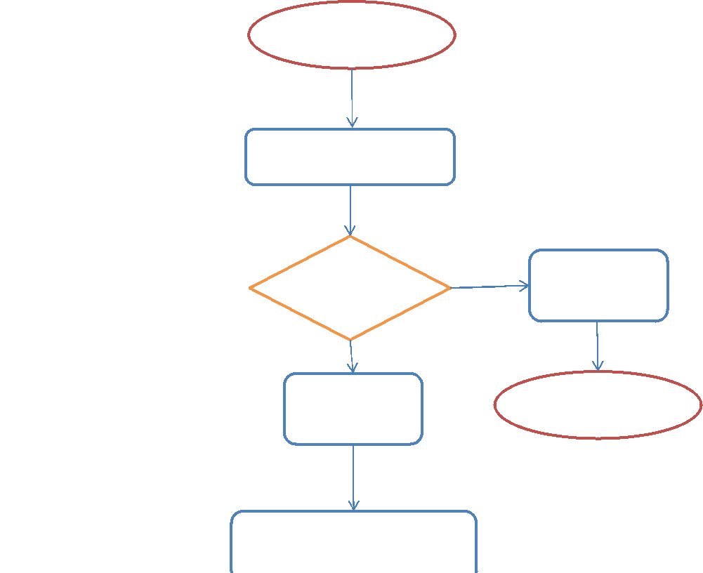
Alert / Surveillance
4.7. FLOWCHART
IMT ESCALATION PROCESS
No
Yes
Response required?
Close and document
Identify and investigate event
Raise to incident and establish
IMT
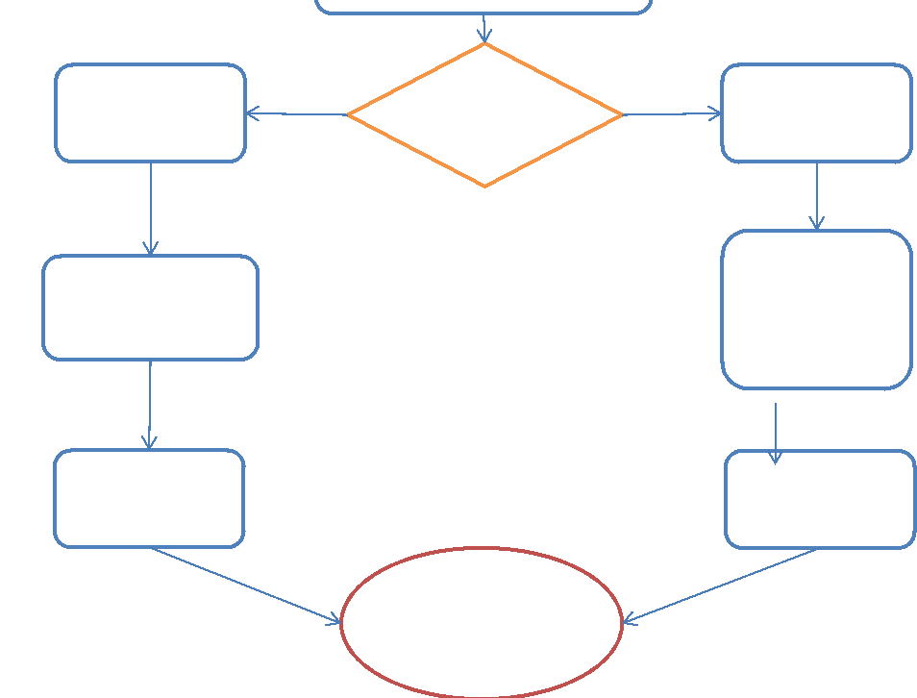
Environmental
Causative agent?
Communicable
Trigger Outbreak Plan if evidence of communicable
disease
Manage through OCT
Close, document
outcome and
debrief
Trigger
Environmental
Incident Guidance
Manage through IMT

4.8. BOX 1. CRITERIA FOR ESTABLISHING AN INCIDENT MANAGEMENT TEAM (IMT).
An exceedance of drinking water standards (e.g. a prescribed concentration or value (PCV)) and guidelines as set out in the Water Supply (Water Quality) Regulations (Wales) 2018 (link) the Private Water Supplies (Wales) Regulations 2017 (link) that is unacceptable in terms of public health (termed a non-compliance event).

- Reports of an unusual deterioration or changes in water quality that may have an implication on public health. For example, analytical data suggesting increase metal or pesticide concentrations, changes in colour or turbidity that may indicate a change in the water treatment process.
- Reports of failure or poor performance of water treatment and disinfection activity.
- Reports of potential external contamination of a water supply or water catchment area that could result in a future non-compliance event or near miss (for example diesel spillage threatening water supply).
- Reports of site security issues associated with water supply or treatment process. Note: An Incident of this type would be managed by the water company through their emergency security protocol and may involve other agencies such as the police that may affect the conduct of the incident as described in section 2.4.5.2.4.8
- Any evidence of unusual and unexplained clustering of cases in the community related to a water supply.
- Any significant perceived risk to the health of consumers.
- Significant consumer perception or concern about the quality of the water supplied or changes in water quality.
- One or more core partners have already declared the event a public health incident.
- Any combination of the above.

4.9. BOX 2. EXAMPLES OF CONTROL MEASURES
Immediate:
- Stop water abstraction
- Flushing of supply system or individual supply pipes (e.g. lead pipes)
- Issue warning advice/ notices:
- Boil before Use for drinking and food preparation (BWA)
- Do not use for Drinking or Cooking (DND)
- Do not use for Drinking, Cooking or Washing (DNU)
- Providing alternative supplies, such as:
- Bottled water (also see
http://www.legislation.gov.uk/wsi/2015/1867/contents/made)
- Bowsers and tankers
- Diverting sources or Re-zoning (introduction of water from a different supply)
Long-term / permanent:
- Additional water treatment processes (process control)
- Activated carbon
- Water filters
- Increased disinfection
- Phosphate dosing
- Replacement of water pipes e.g. lead pipes
- Permanent provision of different supply (e.g. moving from private water supply to mains)
Public Health controls:
- Isolate or exclusion of cases and contacts
- Screening and monitoring of contacts
- Immunisation or prophylaxis
- Specific advice and interventions to highly susceptible groups e.g. protection measures for:
- for immunocompromised groups
- recommend home dialysis patients receive treatment in hospital
- lead exposure and children
- bottled water and infants

4.10. FLOW CHART 2. CORE PARTNERS ROLE IN DECLARING IMT
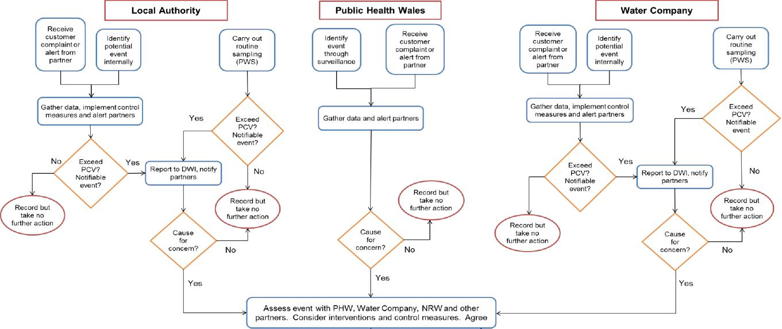
Water Company
measures and alert partners
Gather data, implement control
Receive customer complaint or alert from
partner
⁻1 Identify potential event internally
Carry out
routine
sampling
(PWS)
Yes
Record but
take no
further action
No
Yes
Cause
for concern?
Yes
No
Gather data and alert partners

Record but
take no
further action
No
Yes
{Assess event with PHW, Water Company, NRW and other partners. Consider interventions and control measures. Agree

Cecord but further action take no
Cause
for
concern?
Yes
Public Health Wales
Receive customer complaint or alert from partner
₁
Gather data, implement control
measures and alert partners
/
No,/ Exceed \ Yes r
PCV?
Notifiable /
event? /
Local Authority
Carry out
routine
sampling
(PWS)
Identify potential event internally
Identify event through surveillance
Receive customer complaint or alert from partner
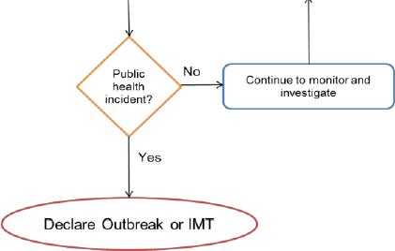
Continue to monitor and investigate
Report to DWI, notify
partners
•
Page 48 of 88
Version: Final
Date: 10 July 2020

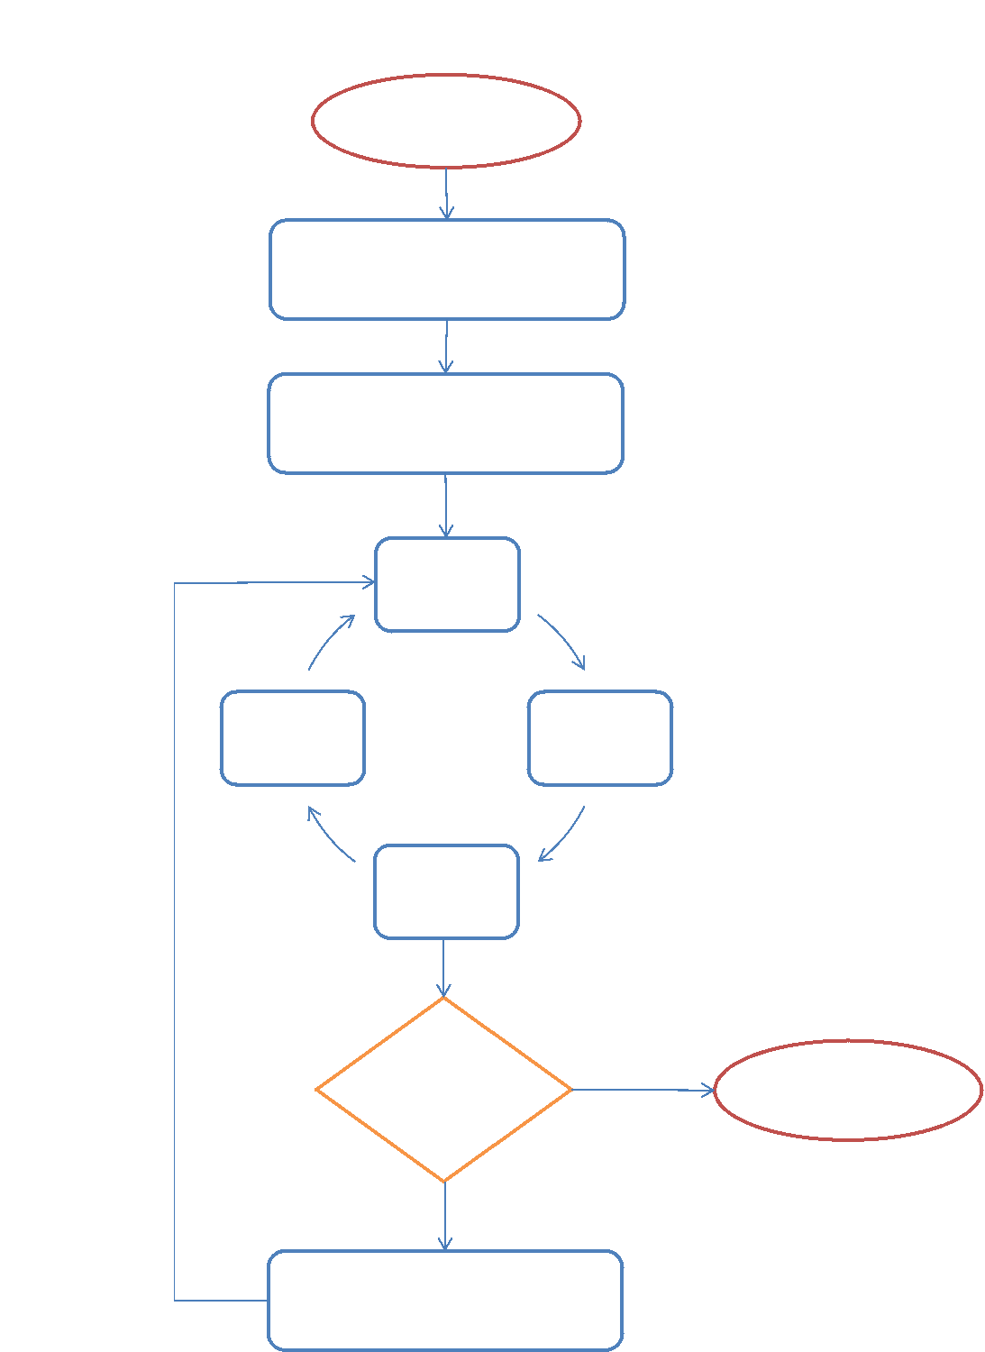
Monitor impact
Monitor cases
and water
quality
Initiate control strategies
Outbreak /
incident
controlled?
No
Yes
Declare over, write up and debrief
Review situation and decide on additional actions
4.11. FLOWCHART
Core actions of IMT
Declare OCT / IMT
Establish OCT / IMT and agree Chair
Review situation and confirm outbreak / incident
Risk assess and
communicate

4.12. Box 3. Epidemiological Evidence Used to Determine Likely Association with Drinking Water
The following evidence that may contribute to defining an outbreak or environmental incident independently of findings related to water treatment and supply:

- Numbers exceeding expected background level for time and place or linked cases.
- Descriptive evidence (person, place, time): A large proportion of cases clustered in water distribution area.
- Strength of statistical association by an analytical epidemiological approach (e.g. case-control or cohort), especially with dose response (risk increased with amount of water consumed).
- Biological plausibility and consistency with natural history of pathogen or chemical.
- Plausibility in terms of descriptive details, outbreak dynamics, spatial and temporal distribution of the chemical contaminants etc.
- Analogy with other waterborne outbreaks (such as the high proportion of adult cases in suspected Cryptosporidium outbreaks).
- Strength of likely association increased by recovery of pathogen from supply or confirmation of chemical exposure.
- Lack of evidence for plausible alternative explanation.
- Case numbers decrease following the introduction of appropriate control measures.

4.13. Box 4. Drinking water warning messages


The type and nature of the warning advice given with depend upon the type and nature of the contaminant and the overall risk assessment
In all cases there is an issue with the public following advice when incidents are prolonged and the IMT should consider repeating warning messages in these circumstances.
The responsibility for the issue of these notices rests with the Water Company at all times.
V
T
Y
S
R
E
E
I
Boil before Use for drinking and food preparation (BWA)
Do not use for Drinking or Cooking (DND)
Do not use for Drinking, Cooking or Washing (DNU)
- Most frequently used.
- Typically for microbial contamination.
- Can cause inconvenience among the public and can be disruptive to certain businesses (food and drink retailers etc) and public buildings (health care premises).
- Public are familiar with the concept.
- Less frequent.
- Used for events which cause acute health effects such as chemical contamination.
- Public and businesses may be less familiar with such restrictions and will require careful communication.
- Can present a more significant challenge due to the need to provide alternative water supplies for drinking and cooking.
- Rare
- Used for events where contamination presents both an acute risk and where contact is potentially hazardous.
- Public and businesses may be less familiar with such restrictions and will require careful communication.
- Potential hygiene issue relating to the need to restrict/prevent access to water for showering and bathing.
- It is recommended that DNU notices are reserved for use only in those circumstances where there is unequivocal evidence of persistent contamination of the water supply with a chemical or radioactive substance at a concentration where short‐term exposure is likely to give rise to adverse health effects including dermal effects.
4.14. Checklist: Risk assessment
Checklist: Risk assessment (1 of 3)
Assessing the hazard
fl What is the source of the water? Surface water, groundwater, public or private supply
fl What is affected?
- Treated water supply
- Boreholes / well reservoir/river
- Residential, commercial property
- Public building
fl Identify actual or suspected contaminants
- Chemical
- Biological
- Radiological
fl What testing has been undertaken or is planned?
- What samples have been taken and what analysis should be done
- Analytical techniques and timescale for analysis.
- Availability of historical water quality testing data (e.g. is this a recurring event)
fl Is it biological?
- What it the organism involved?
- What is the incubation period?
- Seriousness of the disease – pathogenicity, virulence.
- Mode of transmission.
- Susceptible / vulnerable persons?
fl Is it chemical / radiological?
- Acute and chronic toxicity
- Is there a latency period and/or delayed effects?
- Main route of exposure?
- Susceptible / vulnerable persons
- Identify possible cross reactions with water treatment chemicals and potential for harmful by-product formation
fl Is the current data sufficient or is more data needed.
Communicable Disease Outbreak Plan for Wales 2020
Checklist: Risk assessment (2 of 3)
Assessing Exposure
fl Define the population at risk
- Who is currently affected/exposed?
- Populations at risk of future exposure?
- Identify high risk populations (e.g. hospitals, nursing homes, dialysis patients, children, areas at risk from back siphonage)
- Consider mapping affected areas.
fl What is the likely duration of the incident?
- Travel time within the water supply system or water course under normal operating conditions.
- How will remedial measures such as re-zoning, high velocity flushing affect time estimates.
fl How long have people been exposed?
fl Collect epidemiological information on cases / exposed
- Person (age, sex, occupation)
- Place (residence, recent travel history etc)
- Time (onset of symptoms)
fl Laboratory results, confirmation of diagnosis or exposure (e.g. biomonitoring) fl Is the current data sufficient or is more data needed?
Operational issues
fl What water treatment is in use?
fl Gather information :
- Any loss or any change in water treatment
- Water treatment performance
- Proposals for any additional treatment
- Risks of ingress through e.g.: ingress or back-siphonage
fl Proposed water storage and distribution measures?
- Provision of tankers
- Bowsers
- Bottled water
- Re-zoning
Communicable Disease Outbreak Plan for Wales 2020
Checklist: Risk assessment (3 of 3)
Key public health actions
fl Define case
fl Compare measured concentrations in drinking water with relevant health based guidelines and standards.
fl Assess plausibility (biological, temporal, spatial) between exposure and symptoms
fl Determine probable health effects following exposure especially for high risk individuals
fl Consider population health surveillance.
fl Consider descriptive or analytical epidemiological study to evaluate impact on health
fl Consider other risks such as back-siphonage and disinfection by-products.
fl Issue advice to public, health professionals, local authorities etc.
fl Consider use of helplines and/or social media to communicate with public, patients and partner agencies.
fl Ensure provision of medical care such as GPs/Primary Care, Hospitals etc.
fl Agree and initiate control measures to reduce exposure such as immediate issuing of warning notices, provision of alternative supplies, additional water treatment.
fl Developing the criteria for declaring incident over.
fl Prepare a written report on the incident.
fl Debrief and disseminate any lessons learnt.

